DocBot AI – Document Extraction System
DocBot AI is a smart document extraction and question-answering system designed to help users interact with their uploaded files. It supports multiple file formats such as PDF, DOCX, TXT, and CSV, allowing users to extract meaningful insights through uploaded files.

Case 1: No File Uploaded
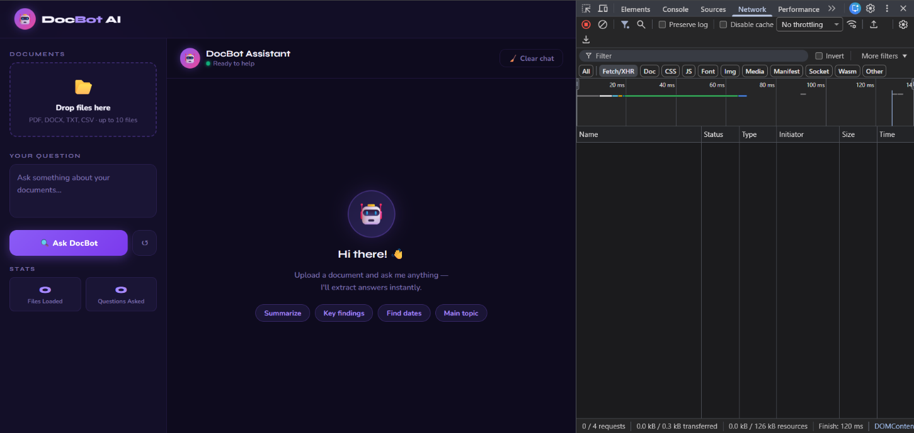
Case 2: Single File Uploaded
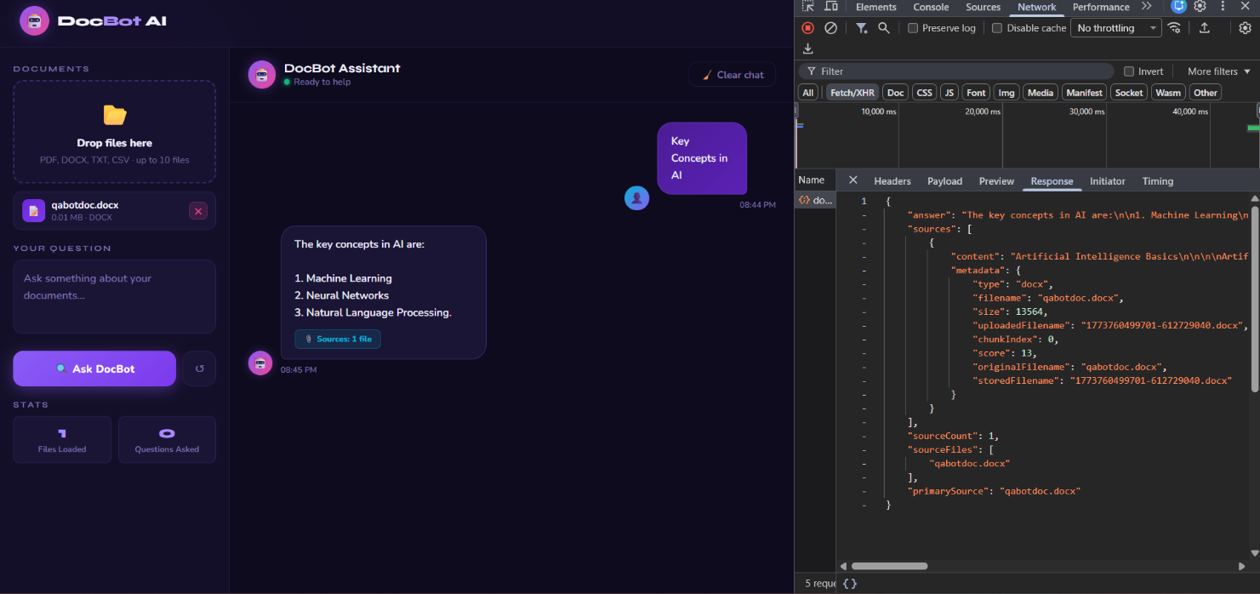

Case 3: Multiple File Uploaded
